
BOWDON CONSERVATION GROUP
Registered as a charity since 1973. Reg. No. 502689
www.bowdonconservationgroup.co.uk
Chairman: Kate Stross

Minutes of the Bowdon Conservation Group committee meeting which took place on Tuesday 3rd September 2024 via the Zoom app
PRESENT
Kate Stross (Chair)
Mike Ward
Gordon Desser
Neil Morton
Sue Meakins
Joyce Gatoff

APOLOGIES
Tony Goodman
Nigel Haworth
Loretta Mooney
Simon Nicholas

1. Minutes of the Meetings 23rd July 2024 & 26 August 2024
Approved

2. Ongoing Planning Applications
2023
111172/OUT/23 | 9 Bowgreen Road - outside C/A | Demolition of house, erection of 2 semis | Awaiting – appeal lodged
111432/HHA/23 | Oakleigh, 12 Higher Downs WA14 2QL | Application to replace existing wooden gates with black metal gates retaining original posts | Awaiting - road is Dev CA, house is not!
2024
113171/HHA/24 | Beech Bank, Bowdon Road | Alterations to roof, single storey rear extension garage to living space. Replacement windows | Awaiting
113458/HHA/24 | 1 Beechfield | widening of driveway / reconstruction of wall | Awaiting
113556/HHA/24 | Robinswood, 35 Cavendish Road | new single storey garage, old garage to living space. | Awaiting
113916/HHA/24 | Perdu, 9 St Margaret’s Road | Above ground extension – objection raised | Awaiting
113943/FUL/24 | 5 Gorsey Lane | demolish and rebuild BOUNDARY OF DCA. (not in DCA) | Awaiting

3. Approved / Refused Planning Application Since Last Meeting

108673/FUL/22 | Erlesdene, Green Walk | Refurbishing the 9 apts demolishing outbuildings 5 new residential units | Approved with conditions
108674/LBC/22 | Erlesdene, Green Walk | Listed building consent | Approved with conditions
113532/HHA/24 | 4 Westwood, St Margarets Road | carport to internal space | Approved with conditions
113625/HHA/24 | Donnington, 32 Grange Road | Demolish garage and erect single storey side extension replace windows, wider vehicular access and new wider gate | Refused
113826/HHA/24 | Chesham Place | Widen gate significantly | Refused
113804/CPL/24 | 33 Green Courts | new access – objection raised | Approved
113859/FUL/24 | St. Margaret's church | DCA new antennas + GPS node | Refused
113872/VAR/24 | 1 Bowgreen Road | BCA amending plans / 1 objection height + loss of light | Approved with conditions
113950/HHA/24 | Sunnydale, Bowdon Road | single storey rear extension | Approved with conditions
113490/HHA/24 | 5 Higher Downs | 2 storey side and rear extension | Removed
113844/FUL/24 | Scriven House, Richmond Road | Office to residential | Removed
113845/LBC/24 | Scriven House, Richmond Road | boundary wall = new vehicle access | Removed

4. New Planning Applications
113970/HHA/24 | 1 The Springs, Apartment 2 | Change window to double doors with Juliet balcony | New – check with tree application same address
113980/HHA/24 | Bruera, Heald Close | Solar panels not visible from road | New
113852/HHA/24 | 67b Langham Road | Replace perished brickwork and replace roller shutter with door | New
114041/HHA/24 | Big Tree House, Charcoal Road | Minor changes to works | New – outside CA
114232/HHA/24 | 3 Osbourne Place | Demolition of conservatory, 2 storey extension | New – outside CA

5. Enforcement
Nothing new this month.
No formal update on enforcement request for school banners – but banners by church have been removed.

6. New Tree Applications Since Last Meeting
 | 33 Green Walk | Various works | New – Sue to object and speak to tree officer
 | Big Tree House, Charcoal Road | Removal of beech tree | New – outside CA – Sue to object
 | Oakleigh, Green Walk | 30% reduction, but tree is decayed | New
7. Traffic, Highways and Street Lighting
Carried forward: Traffic monitoring in place in Bentinck / Woodville area – presumably following recent Regent Road and St Margaret’s Road works.
Need to keep impact of A56 crossing under review. Many complaints. LH turns into and from St Margaret’s Rd for coaches are now very tight. Coaches are waiting in Cavendish Rd, obscuring visibility of school crossing - carried forward. NB. A new pedestrian island has now been installed on the A56 for those crossing at the end of Green Walk - a huge safety improvement for walkers to Dunham Massey!

8. Planning Proposals from outside Bowdon
Airport – Neil circulated update (below) which suggests a 5-month delay to April 2025 for next milestone and similar delays thereafter
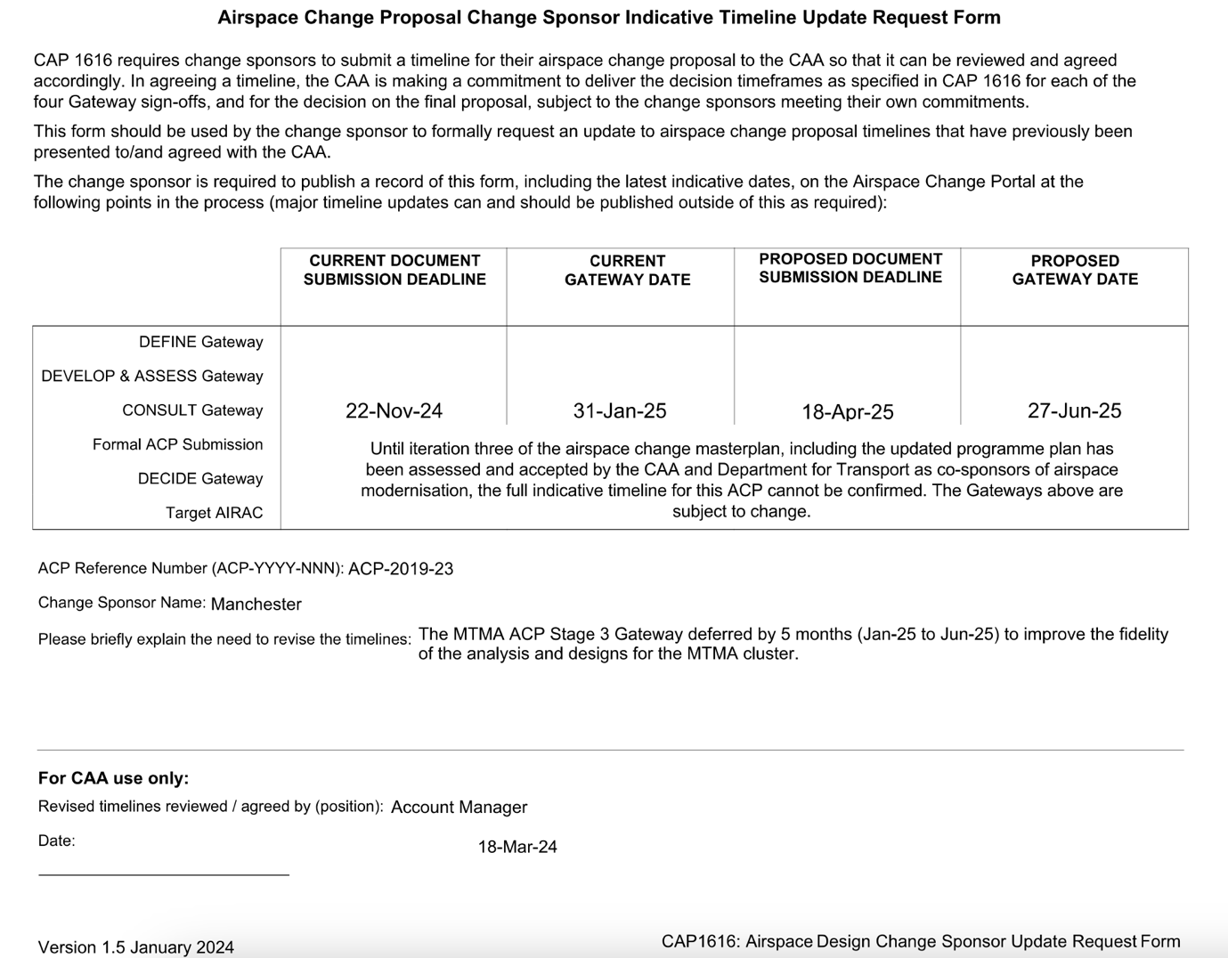

HS2 (alternative schemes) - no update, awaiting decision by new Government
Tatton Motorway Service Station Ref 22/0872M
https://www.messengernewspapers.co.uk/news/24270265.tebay-style-m56-service-station-objectors-not-giving-up/
Application called in by Secretary of State – Angela Rayner is now Secretary of State
Davenport Green – major housing proposal, 2,500 homes, schools, retail, employment – consultation closes 20 September 2024 https://davenportgreenconsultation.co.uk/

9. Membership Secretary’s Report and Treasurer’s Report
No update this month
Anthony and Mike to be added to bank account, Nigel to be removed.

10. Newsletter / Website
Final draft committee minutes agreed between meetings and published on the website as it is updated.

11. Emails and other Member contacts
Nothing this month

12. AOB
AGM – NM suggested approaching a speaker from Manchester Airport once the CAA new flightpath proposals have been published. AGM timing will therefore be dependent on timing of the publication and consultation - carried forward
24/04 - Need to confirm if AGM is a legal requirement - Nigel to confirm we have met our Charity Commission obligations as part of handover to Tony – carried forward
Potential uses for some of our funds:
https://sponsor.treesforstreets.org/provider/trafford-borough-council - could we match fund members who sponsor a tree - carried forward
Grant scheme for walls vs trees to cover all or part of the cost difference - carried forward

13. Dates and Time of Future Meetings
Tuesday 8 October – apologies from Gordon
Tuesday 12 November

